Assignment Front Cover Sheet

TITLE PAGE

Programme of Study: Foundation Degree in Applied Computing

ASSIGNMENT

NAME OF STUDENT: Alexander J Doster YEAR OF STUDY 2

College Email Address:

Unit code: LP20552A1 Unit Title Mobile Technologies

Unit Tutor Danielle Vass danielle.vass@bathcollege.ac.uk

ASSIGNMENT TITLE:

LP20539A1: App Development

WORD COUNT 9687 DATE SUBMITTED 2 December 2015

(May not exceed +/- 10% of limit) (Late submissions may be penalised)

CHEATING AND PLAGIARISM DECLARATION

I confirm the following

*I have read and understood the following sources that explain cheating and plagiarism;*

*the University of Bath website at* [*http://www.bath.ac.uk/library/help/infoguides/plagiarism.html*](http://www.bath.ac.uk/library/help/infoguides/plagiarism.html)

*and my programme handbook*

*To the best of my knowledge, my work does not contain plagiarised material.*

SIGNATURE: A J DOSTER

Ensure that you have completed your work as specified by the deadline date and time (Thursdays 4pm)

You must submit one electronic copy of your work to the relevant location as detailed in the assignment brief and/or the Regulations for Submitting Assignments document.

You must keep a copy (electronic and paper) of this assignment for your own records.

|  |  |  |  |  |  |  |
| --- | --- | --- | --- | --- | --- | --- |
| bath college MONO copy | | Assessment feedback form Students must attach this form and the assessment brief to work submitted for assessment | | | | UoB_logo-blu-xs |
| Hand out date: | | *(as per assessment plan)* | Hand in date: | | | *(as per assessment plan)* |
| Assessor: | | Danielle Vass | Date received: | | |  |
| Assessor’s comments Task 1: Presentation about the past, present and future of mobile apps (20%)  Task 2: Mobile app (70%  Task 3: Demonstrate of the app (10%) | | | | | | |
| Percentage mark awarded |  | | | Contribution to Unit Marks | | 60% |
| Unit Outcomes | * Analyse and recommend an appropriate mobile solution for the workplace. * Demonstrate an understanding of a variety of mobile technologies (e.g. Mobile-device based languages, operating systems, internet browsers and environments). * Produce a mobile application for a given specification. * Research current developments in emerging mobile device techniques. | | | | | |
| Assessor’s signature |  | | | | Date |  |
| Moderator’s signature |  | | | | Date |  |

# Aims

This assignment aims to provide evidence for the learning outcomes of the unit. (See above).

It will demonstrate your ability to do the following:

* Use GUI design and visual programming skills in a given language.
* Show good problem solving skills, Time management and Planning and prioritisation of tasks.
* Prepare high quality reports and documentation to support applications.
* Present information appropriately.
* Perform user demonstrations and prepare questionnaires to aid critical evaluation of products.

# Scenario

You are tasked by a specialist subject teacher to create a **questionnaire Android app**.

The app will test how much information students already know using short questions. For example, a geography teacher might want to establish if students know flags, or capital cities for countries in the World. Students will be given a final score which can be used by the teacher to evaluate their prior knowledge.

You must also come up with at least one additional feature of your own choice e.g. more questions, or question topics.

To achieve the highest marks possible your app should also connect to an API online to retrieve questions. The method of which must be discussed prior to the app submission.

Finally, you must demonstrate a good HCI and incorporate some Material Design aspects into your app.

Your app is required to run on Android 5.0 (SDK 21) and above. It is not necessary to have a real Android device yourself, as Android Studio will provide an emulator to use.

Tasks

1. Create a presentation (with detailed notes) about past, present and future developments in mobile technologies. You are not going to do present this task, it will be submitted electronically. So the presentation should be written to be meaningful to the assessor. The presentation should be approximately 15 minutes of material.
2. A working mobile application that meets the brief, plus fully commented code. (60%)
3. A demonstration of the app 1-1 where students defend their work

# SubMISSION

You should submit via a GitHub repository:

* Folder with all source code for your Android app
* Folder for presentation in a .ptx format (not .pptx)

# Grading Criteria

|  |  |  |  |
| --- | --- | --- | --- |
| Element | Wt. | Criteria | Mark |
| Task 1: Presentation about the past, present and future of mobile apps | 20% | Standard of English | 0 – 5 |
| Multiple Operating Systems mentioned (Android, iOS, Blackberry, Windows Mobile) | 0 – 8 |
| Future tech | 0 – 7 |
| Task 2: Mobile app | 70% | Profile or About Interface | 0-5 |
| Introduction Interface | 0-5 |
| Questions Interface | 0-10 |
| High Scores Interface | 0-10 |
| Persistant Storage of High Scores | 0-5 |
| Questions retrieved from Internet API | 0-15 |
| Bonus feature of your choice | 0-15 |
| HCI and material design | 0-5 |
| Task 3: Demonstrate of the app | 10% | Defence and justification of how app works | 0-10 |

**Alexander James Doster**

**29 September 1984**

**Applied Computing FdSc**

**City of Bath College**

**LP20539A1**

**Mobile Technologies**

**TABLE OF CONTENTS**

**Introduction 7**

**Android 7 - 19**

**Blackberry 20**

**Windows 21**

**Apple 22 - 37**

**Android Phones & Tablets 38 - 39**

**Conclusion 40**

**References 40**

**Introduction**

This report looks at the good and bad points of multiple mobile technologies and operating systems. In particular the systems of Android and Apple.

Android

5 Good Features of Android

|  | **5 Features of Android** |
| --- | --- |
| **1.External Storage** | Micro SD cards for extra storage |
| **2.Connectivity** | BlueTooth/Tethering/NFC |
| **3.Android Pay** | Allows you to pay for items Wirelessly. |
| **4.Voice Based Features** | Voice actions for texting calling and navigation |
| **5.Multitasking** | Doing multiple things at once |
| **6.Accessibility** | Talkback for blind and visually impaired people and other impairments |
|  |  |

1. External Storage is a good feature on an Android phone because it is convenient, the phones are reasonably priced and with external storage. You can just keep upping the size of the SD cards to make extra storage for your app’s and music/photo’s etc. This option for Memory Expansion is not half as expensive as some of the other phones on the market that don’t have that option as you can get a 32gb SD card for £10 from Amazon.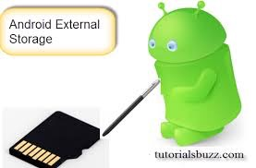

Image above ref google images external storage. accessed 7/11/15 ,7pm

2.(Connectivity)

(NFC)

Near Field Communications is another tool for Android users to share data however NFC is used to send and receive data. It also reads and writes data over passive NFC tags and stickers.

(BlueTooth)

BlueTooth Connectivity allows android users to connect to other phones apart from iPhones. When android connects to a windows phone or another android it can normally receive data and send data for instance you can send wall papers or music from torrent sites.

(Tethering)

The tethering functionality allows you to create your own personal Wifi Hotspot within any location when you have another device that requires Wifi. This however uses your own data but is cheaper than paying for access to a BT wifi Hotspot.

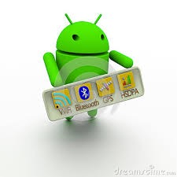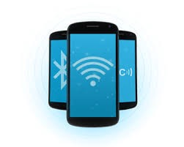

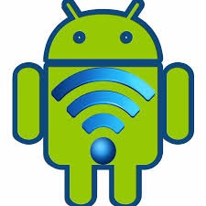

ref google images Connectivity both images. accessed 7/11/15, 7pm

3.(Android Pay)

Android pay is a simple and easy way to pay for things in shops these days because a high percentage of shops are getting the payment Terminals that connect wirelessly to phones. Android has a collection of apps that will allow android pay to work such as Google Wallet, also another one is Banking card reader and the Capital One Wallet, this has made purchasing items really easy.

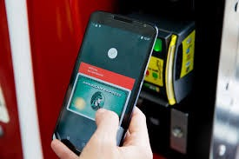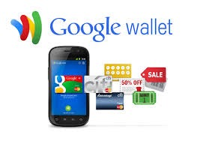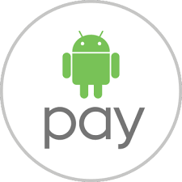

ref android pay and other images at google images android pay. Accessed 7/11/15, 7pm

4. Voice-Based-Features

This function allows the user to interact with the phone by voice and also the phone to interact with the user, such as Navigation gives vocal direction to the end user to the destination. This also allows the handsfree action for end user to speak on the phone while driving or the end user to do a voice text while on the road. This function is good when you are in a car or travelling because these days you are not allowed to physically use a phone while driving .

android voice based features ref google images. Accessed 7/11/15 ,7pm

5. Multitasking

This allows the end user to manage the unique handling memory allocation and how much memory is available as well as multitasking with multiple apps.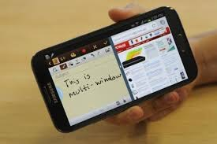

ref google images multitasking.Accessed 7/11/15, 7pm

6. Accessibility

The accessibility functionality provides a built-in-text-to-speech, this is provided by TalkBack. This is for people with impaired vision or no vision, which is classed as a blind person. The enhancements for people with hearing impairments are available as well as other aids.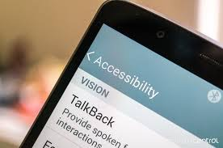

ref google images android accessibility.Accessed 7/11/15,7pm

5 Bad Features of Android

|  | **The Negatives Of Android** |
| --- | --- |
| **1.OS** | Plenty of Bugs and Slow |
| **2. Battery Drain** | No options for preserving the battery life |
| **3. Bad Notifications** | Notifications could be Spammy |
| **4. Connectivity Issues** | Not Connecting to Wifi properly |
| **5.Software Viruses** | Vulnerability of Android |
|  |  |

1. Android Operating System

It’s well known that the android operating system can be slow and very buggy this also has an impact on the apps from google play when app’s need updating. It is certain that the app’s will take longer to update and download and this has been known through many of the android OS such as Jelly Bean and KitKat.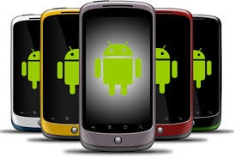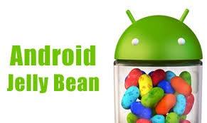

ref google images android operating system

2. Battery Life

Unlike other phones on the market android does not have a method like other operating systems, to preserve the life of the battery throughout the day. This however is not good if the end user wants the phone battery to last through the day.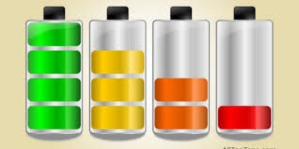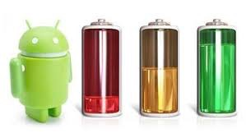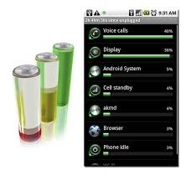

ref google images android battery life.Accessed 7/11/15,7pm

3. Spammy Notifications

The notifications android users get in general just come through one after the other. There is no actual filter in general to organise your notifications and no facility to actually set a time frame for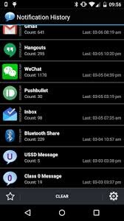 them either they just come straight through .

Ref google image android spammy notifications. Accessed 7/11/15,7pm

4.Connectivity Issues

Android is commonly known for having a lot of Software updates from the Operating System to the app’s however with this it’s known to android users that this causes disruption for connectivity with the wifi as well as bluetooth. The majority of the time it is software a small percentage of the time it is caused by either by dropping the phone or it getting damaged.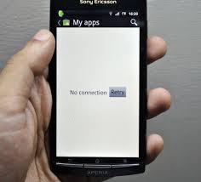

Ref google images android connectivity issues.Accessed 7/11/15,7pm

5. Vulnerability of Android

The Vulnerability of android is very high if you remember going back several months ago there was a Security Risk called Heart bleed. This cyber attack did a lot of damage to a lot of android products as well as windows. Also with this we also know that each of the android OS Systems has either been infected or phones have been jail broken so the outcome of this is that android is really not that secure compared to other Operating System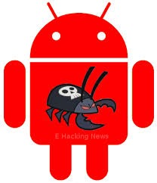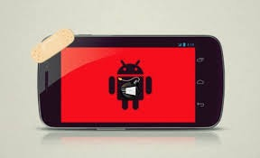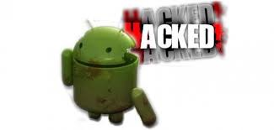

ref google images android vulnerability Accessed 7/11/15, 7pm

Android Versions Of Software

**Android 1.0 - 1.1**

The first android Operating system was used and implemented on an android phone however the first OS that came out was 1.0 and the release of this happened back in September 23rd 2008. This was the public launch of the first phone made by Google, the phone was known as the HTC Dream / T mobile G1. At this point in time the new Software supported new hardware features such as a camera, connectivity feature such as WI-FI/Bluetooth within the connectivity in the settings app. This is the decade that G-Mail started the synchronisation from the web to the G-Mail application also the same scenario happened with Google Contacts and Google Calendar.

At this point in time people found that this OS had lots more features to offer than people realised such as Google Maps and Google Street view Google Search and Google talk which is an in stand messenger, MMS this is multimedia messaging internet etc.

However on February 9th 2009 android 1.0 was updated to android 1.1 which gives some extra functions such as reviews and user searches for business maps. Other functions consisted of longer in-call screen timeout as a default setting when using the handsfree e.g Speakerphone and also allowed to show/hide the dial pad. The update even allowed the user to save attachments in the messages and added support for the marquee in system layouts.

Android OS 1.5 Cupcake

**Android 1.5**

Cupcake OS for android was released almost 3 months later after the release of OS 1.1, the date specified was April 27th 2009 the version of OS was 1.5. ad this release was on phones like Samsung and T mobile. This OS had support for widgets, these are miniature applications such as the home screen and allow the user to receive notifications. It is known that Cupcake had software support for recording videos and video playback in the formats of MPEG-4 and 3GP formats. Cupcake has the functionality for Auto connectivity for stereo support and also Bluetooth such as (A2DP and AVRCP profiles) this also allowed the user copy and paste function within the web browser.

Within OS 1.5 android Cupcake it’s known that user pictures are shown within the contacts and the OS was designed with the date and time stamp to be shown. It also has a call log function and allows one-touch access to a contact card from each call log event.

The API’S within Cupcake allow new functions such as animated screen transitions automatic rotational option and new stock boot animation. It also has functionality to allow the user to upload videos to you tube and the photo’s to Picase.

Android OS 1.6 Donut

Android 1.6

On 15th September 2009, The android 1.6 SDK was released this was based on Linux Kernel 2.6.29 the update included a number of new features.

Donut was officially launched and released 5 months after the previous update for Cupcake however the functionality of Donut is that the OS allows Voice and text entry search with enhancements that include the bookmark history and the user’s contacts as well as the web history. In Donut it has the ability to allow developers to include their content in the search results as we progress further Donut has the functionality of multi-lingual speech synthesis engine which will allow any android app to speak a string of text. The search function has improved and made searching easier as the OS for Android has progressed through time.

The chart below shows the release date of each operating system and the API levels for each OS and also the android SDK number as well.

| **Release Date** | **Api** | **SDK** |
| --- | --- | --- |
| September 23rd 2008 | Level 1 | 1.0 |
| February 9th 2009 | Level 2 | 1.1 |
| April 27th 2009 | Level 3 | 1.5 |
| September 15th 2009 | Level 4 | 1.6 |
| October 26th 2009December 3rd 2009January 12th 2010 | Level 5Level 6Level 7 | 2.0 |
| May 20th 2010 | Level 8 | 2.2 |
| December 6th 2010 | Level 9 | 2.3 |
|  |  |  |
|  |  |  |

Eclair

This was released on the 26th October 2009 this is what is known as the Android 2.0 SDK, this however is based on Linux Kernel 2.6.29 codenamed Eclair.

| **Number** | **New Features of Eclair operating system** |
| --- | --- |
| **1** | Digital Zoom |
| **2** | Bluetooth 2.1 support |
| **3** | Support for different screen resolutions |
| **4** | integrated support for Facebook users |
| **5** | Support for Microsoft Exchange for syncing e-mails |
|  |  |

Listed above are some of the new features that were integrated with the android operating system Eclair. At the time these features came out people were amazed because previously some of the functions listed above were not implemented with the previous android operating system .

FroYo

| **Number** | **New features in FroYo operating system** |
| --- | --- |
| **1** | Improved Speeds |
| **2** | USB teathering |
| **3** | Upload file support within the browser |
| **4** | Allocation features to allow apps to store on expandable memory |
| **5** | Adobe Flash Support |
|  |  |

The new features in Fro Yo which is normally known as frozen yogurt, has improved speeds for connection to the internet and gaming performance, also has improved speeds for USB tethering. Also improved the new function of allowing the end user to upload files to the net via the device at a reasonable speed. However in FRO-YO the system allows the end user to decide where to store the app as it can now be saved on to a memory card as devices have expandable memory.

GingerBread

| **Number** | **New Features in GingerBread operating system** |
| --- | --- |
| **1** | Near Field Communication |
| **2** | Bluetooth car and Desk docks |
| **3** | Android to cloud messaging |
| **4** | Download manager |
| **5** | Improved power management |
|  |  |

These functions allowed the near field communication to allow users to share mp3 tracks via bluetooth and also buy accessories that would charge the device on the desk or play music through a speaker. All this also allowed the devices to have a better power management system and also be able to download mp3 music tracks and use the hands free in the car as well as play music through the stereo.

Honeycomb

| **Number** | **New features in Honeycomb operating system** |
| --- | --- |
| **1** | Universal operating system works on phones and Tablets |
| **2** | Allows end user more control over the interface and home screen |
| **3** | Offers pay as you go support software |
| **4** | Google Books improvement |
| **5** | improved 3G and 4G connections |
|  |  |

This operating system has improved the hardware support dramatically not only that it has increased the ability of applications to access files on the SD Card Synchronisation but also improved the compatibility and display mode between phones and Tablets such as the motorola Xoom while coming out of airplane mode. Also improved all 3G and 4G connections and allowed the android market to allow devices to have automatic updates.

ICE-CREAM-SANDWICH

| **Number** | **New features in ice cream sandwich OS** |
| --- | --- |
| **1** | Better camera performance |
| **2** | 1080p video recording for stock Android devices |
| **3** | Video stabilisation and QVGA resolution |
| **4** | Updated and improved phone number recognition |
| **5** | Stability improvements |
|  |  |

This software was a minor update from other updates and not only that this OS is more a fixing bug software than something with massive improvements and large functions. It is more to do with stabilising the software before an OS comes out as an update to then find out it is worse than the previous version so it’s about stability before major changes come in with the android operating system.

Jelly Bean

| **Number** | **New Features in JELLY BEAN** |
| --- | --- |
| **1** | Security (restricted access for new users) |
| **2** | Performance with the android filing system |
| **3** | 4K resolution support for android phones and tablets |
| **4** | Personalised ring tones |
| **5** | Widgets to personalise home screen |
|  |  |

Jelly bean was a great improvement to the android user as it supported security and restricted access for new users. This meant that the phone would have to be unlocked before it could be used. These days the resolution of TV’S and computers is getting higher and higher so if you record a video on your phone it would mean that if you put it on to disk for a dvd player that was used on a 4k TV, the resolution would be better than if you recorded the video in low quality definition .

KITKAT

| **Number** | **New features in KITKAT** |
| --- | --- |
| **1** | Wearable smart watch API |
| **2** | Infra Red |
| **3** | Offline music playback |
| **4** | GPS Support |
| **5** | Auto focus and HDR |
|  |  |

This Operating System KitKat offers a lot more functions, stability and ways to transfer data from one android phone to another. One of the functions is infra red - it works in a similar way as Bluetooth works only thing is you have to point one infra red port to another infra red port on another phone and then you can transfer messages, music from torrent sites anything that does not have any licensing rights via infra red. The stability of the operating system increased and the GPS connectivity became even more reliable.

LollyPop

| **Number** | **New features in LollyPop** |
| --- | --- |
| **1** | Material design was increased and changed dramatically restyled interfaces |
| **2** | Project Volta this has made improvements for battery life for android users |
| **3** | Additional Languages |
| **4** | More migration between apps and the phone software |
| **5** | Customisable priorities and notifications |
| **6** | Emoticons added to the operating system on the keyboard facility |
| **7** | WI-FI calling |
|  |  |

Apart from the structure of this operating system which shows stability, reasonable connection speeds and speeds for multitasking between apps and e-mails. This also shows that technology for android has slowly but surely moved forward for the simple fact you now have functions such as redesigned interfaces as well as battery life improvements and the ability to choose many languages and emoticons. Android has not moved as fast with technology unlike other companies but is slowly on the way for progression. However WI-FI calling has been around for a while it’s no surprise it has come into android late because it was being tested by others however it is a great function as if you have bad signal it can swap to wi-fi and carry the call on so it is convenient and easy but this is a privilege because it is not just the phone or the operating system but it is down to the network that you are on contract with so it’s more of the case that the phone supports it but might not be provided in your contract plan.

Marshmallow

| **Number** | **New features in MarshMallow** |
| --- | --- |
| **1** | Supports Touch ID |
| **2** | Do Not Disturb Function |
| **3** | Supports USB C |
| **4** | Automatic Data back up’s |
| **5** | 4K display mode for apps |
|  |  |

MarshMallow supports Touch ID like the Apple iPhone this function is available on the new phones that are run on android. However the operating system is very stable, supports the universal serial Bus c port like the iPhone and has the do not disturb function, which stops phone calls or text messages coming through and also in settings there would be a switch that can be pressed to make sure that your phone is automatically backed up and there are facilities that allow apps to run in a 4K mode instead of 1080px.

BlackBerry

| **Number** |  |
| --- | --- |
| **1** | Anti Theft Software |
| **2** | Customizable Ringtone’s |
| **3** | Download Manager |
| **4** | Qwerty and Virtual Keyboard |
| **5** | Customizable home screen |
| **6** | App Store/ downloadable apps |
| **7** | Interactive apps with phone log in accounts/ Blackberry world |
|  |  |

BlackBerry Operating System is very Secure, it has functions such as the Anti Theft Software already built into the phone. BlackBerry is a phone that allows you to customise your ringtone’s and be able to download full length music tracks to play in the music function called multimedia app and also add 3rd party qwerty keyboards as well.

Windows

| Number | Features of windows |
| --- | --- |
| 1 | Customizable Tiles |
| 2 | Universal Software for mobile phones / Tablets/ PC’s |
| 3 | Customizable home screen |
| 4 | X Box live gaming on tablets and phones |
| 5 | Windows app store |
| 6 | Security weak as the same scenario with a windows PC |
| 7 | Spotify and media player |
|  |  |

Above is a table showing features of windows on multiple devices. You can log in to your x box live account from the phone or tablet and start playing your games. It also has similar features to other makes of phone such as blackberry but it’s known that windows phones are weak on security just like the tablets and computers cause of the scale which is worked out as majority to minority. A product that relies on windows is the Surface Pro which is known as a tablet.

Apple’s OS-IOS Beginning

| **mobile OS 1** | **OS1** |
| --- | --- |
| **feature** | Touch centric |
| **name** | OS at the start |
| **Rename** | OS to IOS June 7th 2010 |
| **Device** | 1st gen Iphone |
|  |  |

When apple first launched the Apple iPhone 1st generation the operating system was known as OS 1. This was used to prove that the desktop version of OS could be used on mobile devices, not in the virtual world like everyone thought it would be but in reality. However this operating system was the first of many iteration of Apple’s touch-centric mobile operating systems.

| **Mobile OS 2** | **OS2** |
| --- | --- |
| **Availability** | Released July 11th 2008 |
| **Device** | Iphone 3G |
| **Software Update** | Upgradable software for 1st gen. and 2nd gen iPhones |
|  |  |

When the 2nd generation iPhone was released the new operating system was released. 1st generation devices were the basic cellular connection. GPRS was introduced to the device which allowed surfing the web, however when 3G was introduced with the IPhone connection speeds improved when using facilities like e-mail network connection speeds were a lot better. More functions were introduced to the device and software which then started to expand to more devices such as the iPod touch.

| **Mobile OS 3** | **OS 3** |
| --- | --- |
| **Availability** | Released June 17th 2009 |
| **Software Versions** | OS 3.1.3 |
| **Introduction** | IPad with IOS 3.2 |
| **Device** | Iphone 3GS |
| **Features** | Copy & Paste & MMS |
|  |  |

Within the new operating system there were new features added for example this was the start of Multimedia Messaging Services(MMS) and also the Copy & Paste feature which started a trend and has progressed even more throughout the years as well.

| **Mobile IOS 4** | **IOS 4** |
| --- | --- |
| **Compatibility** | 2nd Generation of iPad (iPad 2) iPhone 3GS iPod touch iPhone 4 |
| **Availability** | June 21st 2010 |
| **versions** | IOS 4.2.1 Nov 22nd 2010 / 2 Golden Masters |
|  |  |

This version of IOS 4 dropped the support for the original version of the iPhone however this version suffered due to the lack of features within the operating system such as multitasking capabilities and also the ability to set the home screen while the iPhone 4 and newer models would not be able to run IOS 4.

| **Mobile IOS 5** | **IOS 5** |
| --- | --- |
| **Released to public** | June 6th 2011October 12th 2011 |
| **Devices it was released to** | IPhone 3GS and IPhone 4 June 6th 2011iPhone 4S/iPod touch 3rd/4th GenerationiPad and iPad 2/October 12th 2011 |
| **Final Release** | Supported the 1st generation of the iPad family also the iPod touchIOS 5.1.1 final release to support the1st Gen iPad iPod touch 3rd Gen |
| **Feature** | (GSM and CDMA) |
|  |  |

IOS 5 was the final version of IOS operating system to support the original 1st generation of iPad’s and 3rd generation of IPods/iPod touches. This meant as support was being dropped for certain devices people would from that year on would have to update devices to the newer products.

| **Mobile iOS 6** | **IOS 6** |
| --- | --- |
| **Release** | This IOS operating System was released in September 19th 2012 |
| **release** | All devices that have been released |
| **Features** | ITunes also over-the-air sharing |
|  |  |

Apple has back tracked with IOS 6 as it offers support to many of the original models of the iPhone 3GS and iPad family as well as iPods however it supports all newer models as well with even more software features and updates.

IOS 7.1

5 Good Features about IOS 7.1

|  | **5 Features of IOS 7.1** |
| --- | --- |
| **1. Accessibility Option** | Switch Head Control |
| **2. Touch ID** | Finger Print ID |
| **3. Auto HDR Camera Functionality** | Automated HDR camera photo Resolution |
| **4.Manual Control of Siri** | Human Control Over Siri |
| **5. IOS 7.1** | Bugs and updates quickly fixed |
| **6. IOS 7.1 Calendar** | Calendar returns to old IOS 6 Functionality |
|  |  |

1. Accessibility

This Option allows you to set up gesture short cuts. What this means is that you can move your head right and left and this is how you can control your phone. However these controls only work if you are facing the camera directly on your device this is accessed if you are on IOS and in settings so you would go Settings >Select General> Accessibility.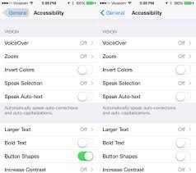

ref google image iOS 7.1 accessibility accessed 7/11/15 7pm

2. Touch ID

The year that IOS 7.1 came out it had Software for the Touch ID, when this was released the hardware for this came out. However 7.1 was the update from IOS 7 and that had issues with the touch ID due to bugs which got fixed but there were quite a few people that had to recalibrate the touch id and finger print id. This was a big thing for Apple as it was a new form of phone Security and in app purchasing.

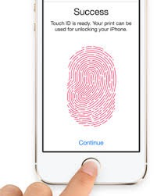

ref google images touch id IOS 7.1 accessed 7/11/15,7pm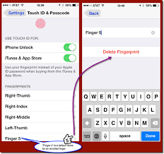

ref google images touch id touch id iOS 7.1 accessed 7/11/15

7:30pm

3. Auto HDR Camera Functionality

IOS and the iPhone at the time of iOS 7.1 was the only phone with Software integrated into the device to give it a HDR tool for photography and increased picture resolution.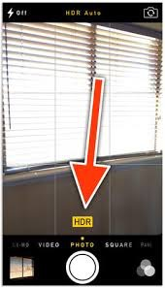

ref google image iOS 7.1 auto HDR accessed 7/11/15, 8:55pm

4. Siri Manual Control

At this point with IOS 7.1 people could choose whether to interact with Siri as you would hold the home button and the Siri Voice would ask you a question and you could choose whether to use Siri or not .

5.IOS 7.1 Operating System

This operating system had constant bug fixes and each bug was updated within 24 hours of the bug reported which is a lot more efficient than android and would also be included with full system updates as well.

6. IOS 7.1 Calendar

The Calendar functionality in IOS 7.1 has gone back in time for redesign however this has lessoned the functionality back to a previous IOS 6. This happens due to redesign of the application and tweaks to the functionality and then the software updates to the current version with plenty of modified functionality.

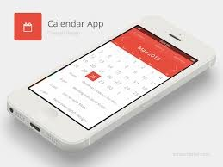

ref google image iOS 7.1 calendar accessed 7/11/15, 8:55pm

5 bad features about IOS 7.1

|  | 5 bad features about IOS 7.1 |
| --- | --- |
| **1. Design** | Flat and colour schemes |
| **2.Calendar App** | Lacked functionality unlike other apps such |
| **3.Lack of control over stock apps** | Can't delete stocks |
| **4. InterFace** | Rather Busy |
| **Apple Apps** | Cant remove them |
|  |  |

1. Design

The Design was pretty flat and the colours were changed with too much white and shading and transparency, but this could be changed in the settings. The icons had a strange weedy looking effect as well and the way certain things worked were a mess.

2.Calendar app

It’s known that a lot of complaints with IOS 7.1 are the fact there is a lack of functionality with certain app’s in IOS 7.1 Also the navigation has been an issue so this operating system has been neglected.

3. Lack of control over stock app’s

The thing with the lack of control with the stock apps is the fact that the design looked more like a bookshelf than anything else. Certain devices like a desktop you could create a folder and hide them on the phone but with IOS 7.1 you could not do that.

4. InterFace

The new and futuristic design of IOS 7.1 was the start of apple’s new generation of operating system design with the opacity colours and the transparency. The control centre that comes up from the bottom of the screen that was split into multiple sections, top section with functions such as airplane mode and then you had brightness then the music player after that it was broken into two sections such as air drop and Airplay then you had touch calculator and camera. This however replicated a busy screen on a device.

5. Apple Apps

Unlike Android you cant remove apps that the designers automatically put on the operating system which you can with the android software .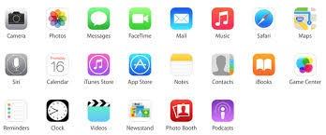

ref google image apple apps accessed 7/11/15,9:00pm

IOS 8

5 Good Features about IOS 8

|  | 5 Good Features about IOS 8 |
| --- | --- |
| **1.Interactive Notifications** | Allows you to respond quickly |
| **2. Battery Monitoring** | Allows you to Monitor the battery life |
| **3. Keyboard** | Allows 3rd party keyboards |
| **4.Spotlight Search** | Interactive search function |
| **Released** | 8th June 2014 |
|  |  |

1.Interactive Notifications

This is a great feature because it allows you to respond to e-mails and texts and also calendar invitations straight away. Also this means while you are on Facebook or surfing the web and you get a message come up you can immediately reply back this is not a feature on android devices only IOS devices.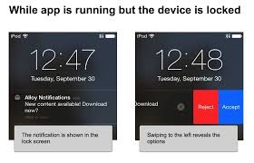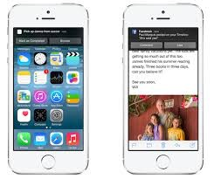

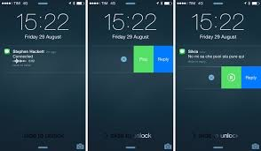

ref google images iOS 8 interactive notifications accessed 7/11/15, 8:50pm

2. Battery Monitoring

With IOS devices it is a great thing to be able to monitor the battery life because it allows you to see what apps are draining the battery life so quickly and may be allow you to decide whether to reduce your usage on certain apps or make sure you properly close all applications down after use - this is not something that is known to android devices.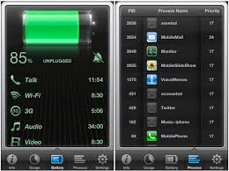

ref Google images IOS battery monitoring accessed 7/11/15, 8:45pm

3. 3rd Party Keyboards

This is an unusual feature as other operating systems on mobile devices such as windows or android do not allow custom keyboards. You can create your own designs with images and emoticons and colours also qwerty keyboards and swipe keyboards too.

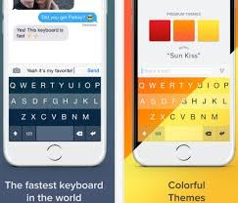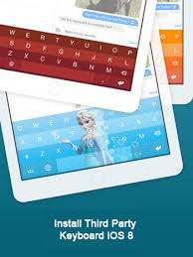

ref Google images IOS 3rd party keyboards accessed 7/11/15 , 8:39pm

4. Spotlight Search finds more

This function can search the web as well as events locally and local restaurants, movies as well as local news and fuel stations and can go straight to navigation if required. It will also search a particular e-mail that is required or a particular message that is required by the end user. This is a function that is not used by android. 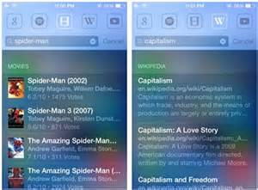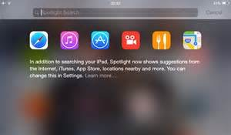

ref google image iOS 8 spotlight search accessed 7/11/15, 9:20pm

IOS 8.1

| **Good features** | **IOS 8.1-8.1.1-8.1.2-8.1.3** |
| --- | --- |
| **IOS 8.1** | Bug fixes also kills the Jailbreak on the iPhone |
| **IOS 8.1** | PassBook , |
| **IOS 8.1** | Apple Pay |
| **Ios 8.1** | Add multiple fingers to Touch ID |
| **iOS 8.1** | Text Message Forwarding |
|  |  |

When IOS 8.1 was released it fixed a lot of bugs and also killed the TaiG jailbreak and had new apple software patches too. After that we then moved on to the next IOS update which was IOS 8.1.1 this was a small update for a bug fix as well as a wifi connection update. After this the next software updates came along within days because the software had been jailbroken and had lots of bugs which meant that apple had to fix the bugs and security issues before other features were implemented.

Apple Pay

This is a good feature because it allows you to pay for items using your phone. The chip used is what they call a near field communication chip. Just pull out the phone and pay, this saves you having to go into your wallet and get your cash card out to pay for things.

PassBook

Passbook is a feature that can be used to check into hotels and board flights within airports automatic check in and it holds the boarding pass within the phone which means unlike the old days where you had paper you now do it electronically with the iPhone or Apple Watch and iPad as well.

| **Good Points of IOS 8.1** | **Good points of IOS 8.1** |
| --- | --- |
| **Apple Pay** | Being able to pay contactless from a mobile device |
| **performance** | Good battery life, speed improvements , Responsive |
| **Connection** | Good wifi connection and cellular connection. |
|  |  |

| **bad points of iOS 8.1** | **BAD POINTS OF IOS 8.1** |
| --- | --- |
| **dot release** | Not a full release as another update due within weeks of launch |
| **Safari** | Extremely buggy pages keep failing to load |
| **Software** | Not up to resolution with the hardware and the advances with the next generation of iPhones |
| **Performance** | Pretty slow in certain tasks other types of tasks not bad |
| **MultiTasking** | Multi Tasking was not great |
|  |  |

The table above shows the bad points of IOS 8.1 and some of the issues and compatibility errors with certain things. Also points out that performance while multi tasking is not great, surfing the web was not that great and it was a situation of having to use a 3rd party app such as google chrome to browse the internet as an apple user it is something that is needed.

| **Good points of IOS 8.2** | **Good points of IOS 8.2** |
| --- | --- |
| **Security** | Passwords, find my iPhone, secret questions,Apple ID,PGP Key |
| **Apple Watch Connectivity** | Apple Watch control |
| **Stability** | Software and app stability |
| **Enhancements** | Software app enhancements |
|  |  |

With the new generations of apple Software And Hardware it is known that the security gets higher and higher every year with every product such as encryption and pop keys as well as finger print ID and passwords. It is also known that Apple focus a lot on how to make mobile devices secure and to make every device private for every end user.

This IOS 8.2 included the Apple Watch control on the phone so what happens is the phone links to the watch and to control certain features of the watch the phone has to be used. The phone has all the settings for the watch and what this means is anything you do not want on the phone you can turn off by going into the apple watch app.

However IOS 8.2 was focused on app enhancements and stability for Apple users with multiple bug fixes and health app improvements and Apple Watch Support.

| **BadPoints of IOS 8.2** | **Bad Points of IOS 8.2** |
| --- | --- |
| **Advised to Avoid 8.2 Install** | Advised to avoid 8.2 software update as it was so buggy |
| **lots of problems** | iPhones freezing,Iphone’s crashing, lots of bugs and glitchy Software |
|  |  |

The bad points of IOS 8.2 were that some Apple users with a minority of the devices sold suffered the Blue screen of death and on top of that a lot of glitchy software and multiple cases of other issues with the IOS 8.2 software . The problems were plaguing the iPhone 6 more than other devices as Apple had put IOS 8.2 on to a piece of hardware that was more advanced than the software so it caused lots of technical errors and issues.

All the Software Apple has developed was for multiple devices such as the iPhone hardware and Tablet hardware as well so the software is technically known as multi platform because it is used with phones just as much as it is used with Tablets such as the iPad Family.

IOS 8 supports apple devices from the iPhone 4S through to the new iPhone 6 and 6+ and also even the newer models such as the iPhone 6S and the 6S+.

IOS 9

Current Features of IOS 9

| **Mobile IOS 9** | **Current Features of IOS 9** |
| --- | --- |
| **Car Play** | Support for wireless CarPlay/ access car settings through car interface/battery indicator added to a on screen display/ also full support for the car knob controls/ scrolling features notification widget/ message play back find my iPhone. |
| **Health** | Accessible Landscape Views |
| **iBooks** | Extensions to turn a web page into a pdf format which allows the user to read and open in iBooks |
| **Siri** | Voice activation/ handsfree by voice/ask Siri questions /play music automatically |
| **Spotlight Search** | Easy search /fast search/ user friendly/ |
| **3D touch** | Press hold option automatically appears on screen without going into the application only available on 6S and 6S+ |
| **3rd party Keyboards** | Ability to add additional keyboards and add additional language keyboards |
| **WI-FI assist** | Switch from cellular network to wifi connection in areas of bad signal |
| **Wallet** | Apple pay / auto check in at airport/ store loyalty cards |
| **wallpapers** | Customisable wall papers and wall papers but certain wall papers are only available to 6s and 6s+ and they are called live wall papers. |
| **Apple watch** | Apple watch settings control app |
| **Bluetooth** | 4.2 connectivity this was added secretly to the iPhone 6 in 2014 |
| **Home Kit** | A IOS 8-9 home automation control app lights / boiler / door locks/ much more |
|  |  |

The features above are currently available with the current mobile and Tablet device operating system IOS 9. Some of these features are similar to the android features on the new android phones such as the Samsung S6.

Apple iPhone spider diagram

Iphone 3G os1

Iphone 3GS os2/os3

Iphone 4 iOS 4

Iphone 6S+ iOS 9

Iphone Models

Iphone 4S iOS 5

Iphone 6S iOS 9

Iphone5 iOS 6

Iphone 6+ iOS 8

Iphone 6 iOS 8

Iphone 5 S ios7

ref. Google images, apple software

This diagram shows all the Mobile phone devices that were made by Apple with the two types of software at the beginning it was OS software then about 2-3 years down the line Apple decided to rename the OS to IOS on the mobile device side of things .

Apple iPad Tablet Family

This spider diagram will show the generations of the iPad with the operating systems in the order of release.

Ipad 2nd generation IOS 4-5

 

1st Generation Ipad IOS 4

Ipad 4th Generation

IOS 5-6-7

Ipad Mini 3rd Generation

IOS 7-8-9

Ipad Mini 1st Generation

IOS 5-6-7

Ipad Air 5th Generation

IOS 6-7-8



Ipad Mini 2nd Generation

IOS 6-7-8

Ipad Pro New Generation

IOS 9+

Ipad Air 2 6th Generation

IOS 7-8-9

Ipad 3rd Generation

IOS 5-6-7



Ipad Generations

This diagram specifies the generations of family over the years and the

operating systems that are implemented to each and every Tablet made by Apple .

ref. Google images Apple operating system family

| **Ipad Generation** | **Ipad Model** | **Cellular &WI-FI &WI-FI ONLY** | **Colour** | **IOS /OS** | **Storage Capacity** | **Release Date** |
| --- | --- | --- | --- | --- | --- | --- |
| **1st Generation** | A1337 | 3G & WI-FI enabled or WI-FI only | white/Black | IOS 4 | 16GB/32GB/64GB | 4/03/2010 |
| **2nd Generation** | MC769LL/A | 3G & WI-FI enabled or WI-FI only | white/Black | IOS 4/5 | 16GB/32GB/64GB | 3/11/2011 |
| **3rd Generation** | MC769LL/A | 4G & WI-FI enabled or WI-FI only | white/Black | IOS 5-6-7 | 16GB/32GB/64GB | 3/15/2012 |
| **4th Generation** | Wi-Fi + Cellular | 4G & WI-FI enabled or WI-FI only | silver/white/black | IOS 5-6-7 | 16GB/32GB/64GB | N/A |
| **Ipad Air 5th Generation** | MD788LL/A | 4G & WI-FI enabled or WI-FI only | black/silver/white | IOS 6-7-8 | 16GB/32GB/64GB | 2012 |
| **Ipad Air 2 6th Generation** | MH182LL/A | 4G & WI-FI enabled or WI-FI only | Gold/Silver/Space Grey | IOS 7-8-9 | 16GB/32GB/64GB | 2013 |
| **Ipad Mini 1st Generation** | MD531LL/A | 4G & WI-FI enabled or WI-FI only | white/black/silver /grey | IOS 5-6-7 | 16GB/32GB/64GB | 2012-2013 |
| **Ipad Mini 2****2nd Generation** | ME276LL/A | 4G & WI-FI enabled or WI-FI only | white/silverSpace grey | IOS 6-7-8 | 16GB/32GB/64GB | 2012-13-14-15 |
| **Ipad Mini 3****3rd Generation** | MGYE2LL/A, MGNV2LL/A, MGNR2LL/A | 4G & WI-FI enabled or WI-FI only | Gold/Silver/Space Grey | IOS 7-8-9 | 16GB/64GB/128GB | 2013-14-15 |
| **Ipad pro** |  | 4G & WI-FI enabled or WI-FI only | Gold/Silver/Space Grey | IOS 9 | 32GB/128GB | 2015 |
|  |  |  |  |  |  |  |

This chart above gives details of model numbers and shows the generation of the iPad and also it tells you the OS /IOS it runs on. This also shows how apple have pushed out so many iPads within the last 5 years unlike other companies that run on android .

ANDROID Mobile Phones

It is common knowledge that android devices are not released as often as apple devices, below will show a table of android mobile phones .

**Samsung**

|  | **Samsung** | **Release Date** | **Operating System** |
| --- | --- | --- | --- |
| **PHONE MODEL** | S6 EDGE | 10/04/15 | Lollipop |
|  | S6 EDGE PLUS | 13/08/15 | Lollipop |
|  | S4 Galaxy | 27/04/15 | KitKat |
|  | S5 galaxy | 11/04/15 | Lollipop |
|  | Galaxy Rugby | 03-2012 | Gingerbread OS |
|  | Note 4 | 17/10/2014 | KITKAT |
|  | **Note 5** | **2016** | Marshmallow |
|  |  |  |  |

The table above shows you a list of mobile phones that are associated with the android operating system and which version of the OS comes with each listed device .

**HTC**

|  | **Htc** | **Release Date** | **Operating System** |
| --- | --- | --- | --- |
| **Phone Model** | HTC ONE M9 | 10/04/15 | Lollipop |
|  | HTC A9 | November 2015 | Marshmallow |
|  | HTC Butterfly 3 | October 2015 | Lollipop |
|  | HTC Desire | 16/02/2010 | Eclair |
|  | HTC one E9 | May 2015 | Lollipop |
|  |  |  |  |

This chart shows another manufacturers handset that comes accompanied by an Android operating system with the release date of each product as well as the name of the operating system that comes with the phone .

Tablets

| **Tablet Make** | **Operating System** |  |  |
| --- | --- | --- | --- |
| **Bush Spira B1** | KitKat |  |  |
| Surface Pro | Windows |  |  |
| Ipad | IOS |  |  |
|  |  |  |  |

The list above shows a small selection of Tablets that are available on the mobile devices market and there are a lot more than the 3 listed and they vary from older to newer models of each tablet even the Kindles come under the selection.

**Conclusion**

In looking at the differences above between mobile phones, tablets and operating systems there really is a mountain of information to consider. There are many different opinions depending on the user requirements and ways that the device is used by each user. The fundamental thing though is the security and reliability of the device. Here is probably where the main differences lie. One of the key things about Android is that it is customisable. This means that you can personalise it and make it look the way you want and add all types of applications. Equally this is one of its downfalls - adding all types of applications with different systems that may not work properly and therefore compromise security and functionality. The Apple IOS operating system has a reputation for being reliable and very secure. It is also known for being easy to use and very intuitive, uniformly laid out and therefore consistent. Apple are pretty strict about the applications that it uses and allows on its devices which are generally only downloaded from the Apple App Store. Due to these limitations the Apple operating system has an excellent reputation for being stable and user friendly. However there is a big difference between the costs for mobile devices with Apple being much more expensive.

What does the future hold for mobile technology? There is no doubt that they will be become more embedded in our day to day lives. We can now use them to pay for things in shops so things may expand into other currencies so payments could be made abroad, using the phone to control our home environment and wearable technology like the Apple Watch and other Android wearables will no doubt expand. HTML5 will be essential for developers to deliver applications across multiple platforms. Well, there are many things that we can have a go at predicting but in the end we will have to wait and see. The networks and Wi-fi capabilities will need to keep up.

References

[www.brighthand.com](http://www.brighthand.com)

[www.information-management.com](http://www.information-management.com)

google images